**Domain Controller to Active Directory Install-Documentation**

Drayson Sanders: DCS101@pitt.edu

30 September 2019

This Documentation Contains step-by-step instructions to be able to Install an active Directory and second Domain Controller to the active directory domain Sysadmin.local.

**Installing Active Directory**

1. Open Server Manager from the Windows start menu
   1. Click Manage on the top right of the Server Manger Window
   2. Click Add Roles and Features

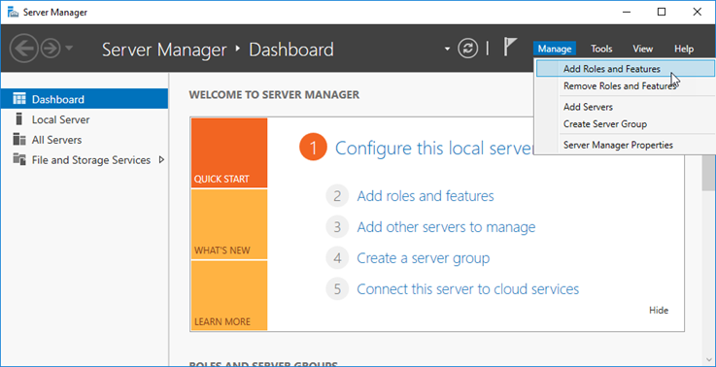

1. Add Roles and Features Wizard popup
   1. ‘Before you begin’ window appears🡪click Next
   2. On the installation tab click the radio button for ‘Role-based or Feature-based Installation’
   3. Under the Server Selection tab click the radio button to ‘Select a server from server pool’🡪Then select the server from the selection box below
   4. Server Roles tab pops up🡪Select Active Directory Domain Services then click ‘Add Features’
   5. Click next then clicked next again under the features tab and AD DS tab
   6. Lastly click install under the confirmation tab
   7. The results tab will appear🡪Select the blue link that says ‘Promote this Server to a Domain Controller’
2. Clicking on this link will open the ‘Active Directory Domain Services Configuration Wizard’
   1. Under the ‘Deployment Configuration’ tab select the last radio button that says ‘Add a New Forest’ then enter a root domain name
   2. In the Domain Controller Options tab select both Forest and Domain functional levels
   3. Then select the check box for ‘Domain Names System (DNS) Server’
   4. Enter the Directory Services Restore Mode (DSRM) Password (this will allow admins a way to safe boot windows servers to restore/repair Active Directories)
   5. In the next tab titled ‘DNS Options’ an error will appear 🡪 Ignore this error and click next
   6. In the next ‘Additional Options’ tab you are able to change the NetBIOS domain name
   7. Under ‘Paths’ tab you can specify the location AD DS
   8. Finally, you can review your options and do a prerequisite check in the final two tabs titled ‘Review Options’ and ‘Prerequisite Check’
   9. After this click install and the server will reboot automatically
   10. The Active Directory is finished

**Adding a Second Domain Controller**

1. Open Server Manager from the Windows start menu
   1. Click Manage on the top right of the Server Manger Window
   2. Click Add Roles and Features
2. Add Roles and Features Wizard popup
   1. ‘Before you begin’ window appears🡪click Next
   2. On the installation tab click the radio button for ‘Role-based or Feature-based Installation’
   3. Under the Server Selection tab click the radio button to ‘Select a server from server pool’🡪Then select the server from the selection box below
   4. Server Roles tab pops up🡪Select Active Directory Domain Services then click ‘Add Features’
   5. Click next then click next again under the features tab and AD DS tab
   6. Lastly click install under the confirmation tab
   7. The results tab will appear🡪Select the blue link that says ‘Promote this Server to a Domain Controller’
3. Clicking on this link will open the ‘Active Directory Domain Services Configuration Wizard’
   1. Under the ‘Deployment Configuration’ tab select the last radio button that says ‘**Add a Domain Controller to Existing Domain’** (This is where it differs from installing an Active Directory and where you put Sysadmin.local) then enter a root domain name

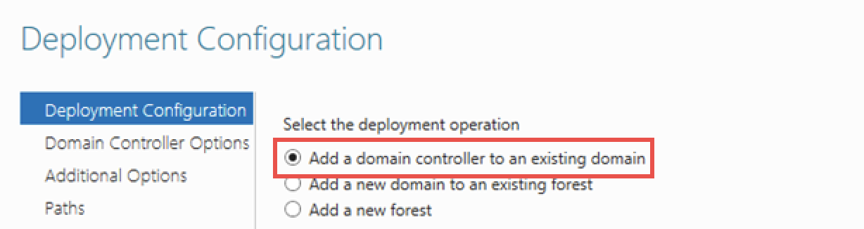

* 1. In the Domain Controller Options tab select both Forest and Domain functional levels
  2. Then select the check box for ‘Domain Names System (DNS) Server’
  3. Enter the Directory Services Restore Mode (DSRM) Password (this will allow admins a way to safe boot windows servers to restore/repair Active Directories)
  4. In the next tab titled ‘DNS Options’ an error will appear 🡪 Ignore this error and click next
  5. In the next ‘Additional Options’ tab you are able to change the NetBIOS domain name
  6. Under ‘Paths’ tab you can specify the location AD DS
  7. Finally, you can review your options and do a prerequisite check in the final two tabs titled ‘Review Options’ and ‘Prerequisite Check’
  8. After this click install and the server will reboot automatically

1. Open Server Manager and click on ‘Local Server’ on the left-hand side
   1. Next to the ‘Ethernet’ property click the blue link titled ‘IPv4 address assigned by DHCP, IPv6 enabled’
   2. This will bring up the Network Connections File Explorer page
   3. Right click on Ethernet connection and select properties
   4. This will bring up Ethernet properties where you should uncheck the Internet Protocol Version 6 (TCP/IPv6) check box (This will avoid possible issues known to be caused by having this check boxed selected)

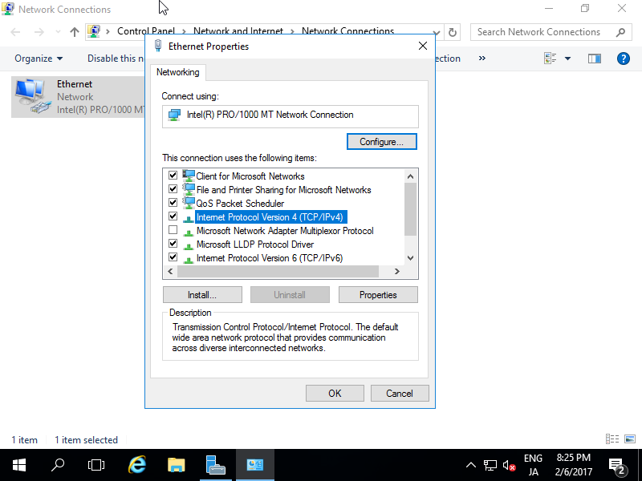

* 1. Next click the properties button
  2. In the next popup window titled ‘Internet Protocol Version 4 (TCP/IPv4) Properties’ select the radio button that says ‘Use the Following IP Address’
  3. Make sure your IP address is different than that of your primary Domain Controller
  4. Use a class C subnet mask (255.255.255.0)
  5. Next make sure the Default Gateway is the same as your first domain controllers
  6. Finally make the DNS the same as your First Domain Controllers IP
  7. The Second Domain Controller is setup